Irregular Quadrilateral-Based Prismoid

Definition
# Source: AI Source: Provided by: [Data Path: Persons Table -> ID Column: 1, Name_En Column: Motasem Essam] -> From: [ChatGPT] on [7/25/2026]
An Irregular Quadrilateral-Based Prismoid is a type of quadrilateral prismoid characterized by two quadrilateral bases lying in parallel planes and connected by four quadrilateral lateral faces.
Unlike prismoids with specific base shapes, such as square-based, rectangular-based, rhombus-based, or trapezoidal-based prismoids, its bases have irregular quadrilateral shapes.
The upper and lower bases may differ in their side lengths, interior angles, dimensions, and overall shapes. The four lateral faces connect their corresponding vertices and form the sides of the solid. <FileCite ref_id="turn1file3"/>

Geometric Structure
# Source: AI Source: Provided by: [Data Path: Persons Table -> ID Column: 1, Name_En Column: Motasem Essam] -> From: [ChatGPT] on [7/25/2026]
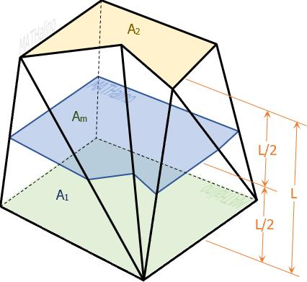
An irregular quadrilateral-based prismoid consists of the following elements:
- Lower Quadrilateral Base: An irregular four-sided polygon forming the bottom face.
- Upper Quadrilateral Base: Another quadrilateral positioned in a plane parallel to the lower base.
- Lateral Faces: Four quadrilateral faces connecting the corresponding edges of the two bases.
- Lateral Edges: Four edges connecting corresponding vertices of the upper and lower bases.
- Altitude (Height): The perpendicular distance between the two base planes.
- Midsection: A quadrilateral cross-section parallel to both bases, located halfway between them.

Face Composition
# Source: AI Source: Provided by: [Data Path: Persons Table -> ID Column: 1, Name_En Column: Motasem Essam] -> From: [ChatGPT] on [7/25/2026]
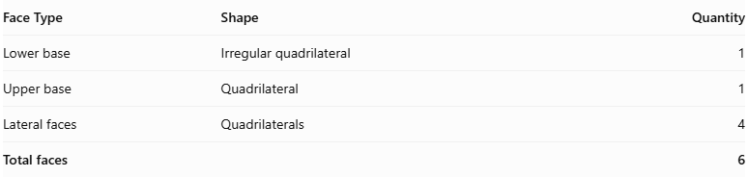
Face Type | Shape | Quantity
Lower base | Irregular quadrilateral | 1
Upper base | Quadrilateral | 1
Lateral faces | Quadrilaterals | 4
Total faces |  | 6
The solid also contains:
- 12 edges
- 8 vertices
- 2 parallel quadrilateral bases
- 4 lateral quadrilateral faces
The lateral faces may be trapezoids or parallelograms, depending on the relative positions and orientations of the bases. <FileCite ref_id="turn1file4"/>

Mathematical Properties
# Source: AI Source: Provided by: [Data Path: Persons Table -> ID Column: 1, Name_En Column: Motasem Essam] -> From: [ChatGPT] on [7/25/2026]
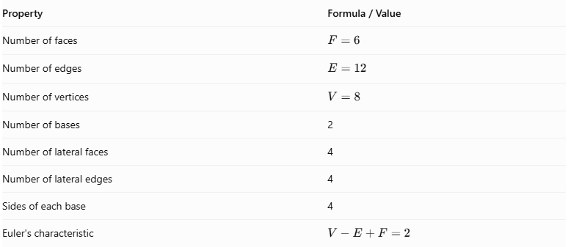
Property | Formula / Value
Number of faces | $$F=6$$
Number of edges | $$E=12$$
Number of vertices | $$V=8$$
Number of bases | 2
Number of lateral faces | 4
Number of lateral edges | 4
Sides of each base | 4
Euler's characteristic | $$V-E+F=2$$
Prismoidal Volume Formula:
$$\boxed{V=\frac{h}{6}(A_{1}+4A_{m}+A_{2})}$$
Where:
- $V$ = Volume of the prismoid.
- $h$ = Perpendicular distance between the two bases.
- $A_{1}$ = Area of the lower quadrilateral base.
- $A_{2}$ = Area of the upper quadrilateral base.
- $A_{m}$ = Area of the midsection parallel to the bases.
Area of an Irregular Quadrilateral:
An irregular quadrilateral can be divided into two triangles using one of its diagonals.
$$A=A_{△1}+A_{△2}$$
For example, if diagonal $AC$ divides quadrilateral $ABCD$:
$$A_{ABCD}=A_{△ABC}+A_{△ACD}$$

Geometric Characteristics
# Source: AI Source: Provided by: [Data Path: Persons Table -> ID Column: 1, Name_En Column: Motasem Essam] -> From: [ChatGPT] on [7/25/2026]
- Irregular Quadrilateral Bases: Both bases have four sides, but their side lengths and interior angles are not necessarily equal.
- Parallel Base Planes: The upper and lower quadrilateral bases lie in parallel planes.
- Four Lateral Faces: The solid contains four quadrilateral lateral faces connecting the two bases.
- Variable Base Geometry: The upper and lower bases may differ in dimensions and shape.
- Inclined Lateral Edges: The connecting edges may be inclined relative to the base planes.
- Convex Structure: In its conventional form, the solid has a convex closed surface.
- Variable Configurations: Its appearance depends on the shapes, dimensions, and relative positions of its two bases.
- Midsection: A quadrilateral cross-section can be constructed halfway between the two bases and parallel to them. <FileCite ref_id="turn1file4"/>

Types of Irregular Quadrilateral-Based Prismoids
# Source: AI Source: Provided by: [Data Path: Persons Table -> ID Column: 1, Name_En Column: Motasem Essam] -> From: [ChatGPT] on [7/25/2026]
The following are possible geometric configurations based on the arrangement of the irregular quadrilateral bases.
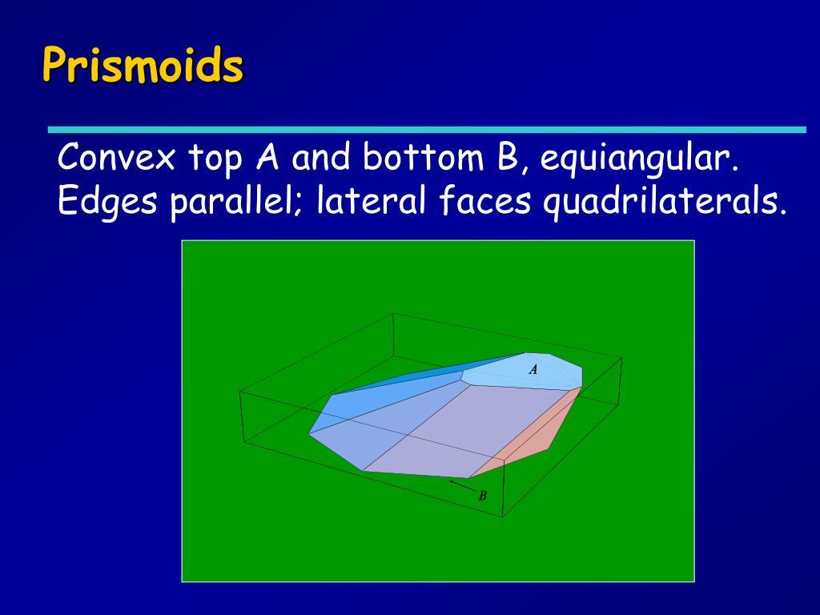
- Right Irregular Quadrilateral-Based Prismoid: A configuration in which the lateral direction is perpendicular to the base planes.
- Oblique Irregular Quadrilateral-Based Prismoid: A configuration in which the lateral direction is inclined relative to the perpendicular direction of the base planes.
- Symmetric Irregular Quadrilateral-Based Prismoid: A configuration in which the bases and connecting faces have a symmetric arrangement despite the irregular base shapes.
- Asymmetric Irregular Quadrilateral-Based Prismoid: A configuration in which the bases and lateral faces have no overall symmetry.
These are descriptive geometric configurations, not a universally standardized classification.

Constructing an Irregular Quadrilateral-Based Prismoid

Geometric Instruments Used
# Source: AI Source: Provided by: [Data Path: Persons Table -> ID Column: 1, Name_En Column: Motasem Essam] -> From: [ChatGPT] on [7/25/2026]
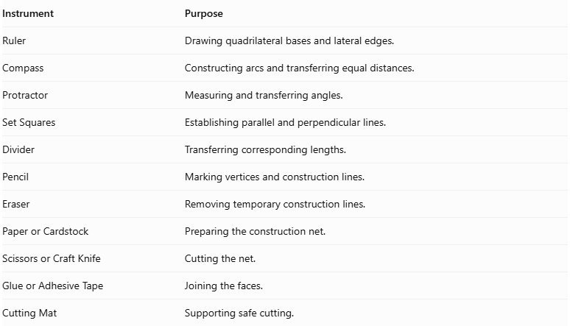
Instrument | Purpose
Ruler | Drawing quadrilateral bases and lateral edges.
Compass | Constructing arcs and transferring equal distances.
Protractor | Measuring and transferring angles.
Set Squares | Establishing parallel and perpendicular lines.
Divider | Transferring corresponding lengths.
Pencil | Marking vertices and construction lines.
Eraser | Removing temporary construction lines.
Paper or Cardstock | Preparing the construction net.
Scissors or Craft Knife | Cutting the net.
Glue or Adhesive Tape | Joining the faces.
Cutting Mat | Supporting safe cutting.

Instrument-Based Construction Procedures
# Source: AI Source: Provided by: [Data Path: Persons Table -> ID Column: 1, Name_En Column: Motasem Essam] -> From: [ChatGPT] on [7/25/2026]
The construction can be performed using three main methods.

Method 1: Construction Using a Geometric Net
# Source: AI Source: Provided by: [Data Path: Persons Table -> ID Column: 1, Name_En Column: Motasem Essam] -> From: [ChatGPT] on [7/25/2026]
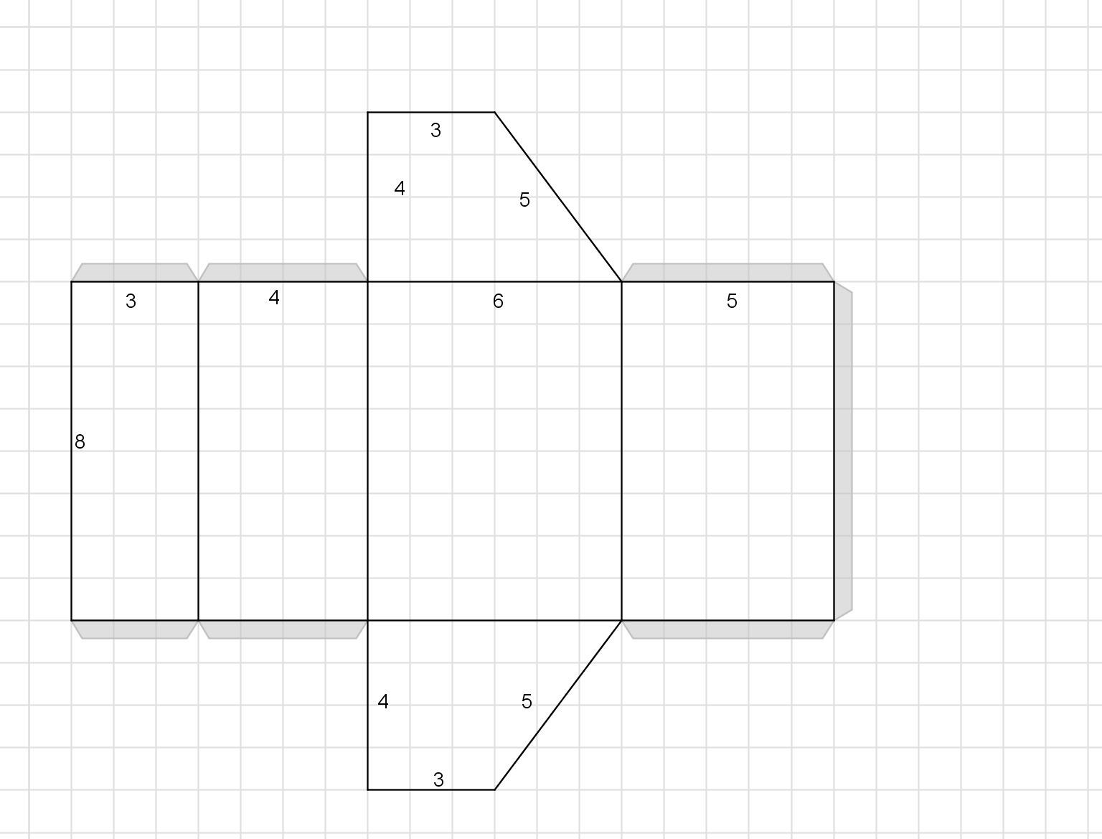
- Determine the Base Dimensions: Choose the side lengths and interior angles of the upper and lower quadrilateral bases.
- Construct the Lower Base: Use a ruler, compass, and protractor to draw the first irregular quadrilateral.
- Construct the Upper Base: Draw the second quadrilateral with its required dimensions and vertex arrangement.
- Determine Corresponding Vertices: Match each vertex of the lower base with its corresponding vertex on the upper base.
- Determine the Lateral Edge Lengths: Establish the lengths connecting the four pairs of corresponding vertices.
- Construct the Lateral Faces: Draw four planar quadrilaterals using the corresponding base edges and lateral edges.
- Arrange the Net: Position the four lateral faces in sequence, with the upper and lower bases attached at their appropriate edges.
- Add Joining Tabs: Include tabs along selected external edges.
- Cut Out the Net: Carefully cut around its external boundary.
- Fold the Faces: Fold along the designated joining edges.
- Join the Structure: Attach the four lateral faces and both bases using glue or adhesive tape.
- Complete the Solid: Check that all six faces meet correctly and that the model closes without gaps.

Method 2: Construction Using Two Parallel Quadrilateral Bases
# Source: AI Source: Provided by: [Data Path: Persons Table -> ID Column: 1, Name_En Column: Motasem Essam] -> From: [ChatGPT] on [7/25/2026]
- Draw the lower base as an irregular quadrilateral and label its vertices $A,B,C,D$.
- Establish the height using a perpendicular reference line between the base planes.
- Construct the upper base plane parallel to the lower base plane.
- Draw the upper irregular quadrilateral and label its vertices $A',B',C',D'$.
- Determine the corresponding vertices:
- $A$ corresponds to $A'$.
- $B$ corresponds to $B'$.
- $C$ corresponds to $C'$.
- $D$ corresponds to $D'$.
- Draw the four lateral edges:
- $AA'$
- $BB'$
- $CC'$
- $DD'$
- Construct the four lateral faces:
- $ABB'A'$
- $BCC'B'$
- $CDD'C'$
- $DAA'D'$
- Check that each lateral quadrilateral lies in a single plane.
- Darken the visible edges and use dashed lines for hidden edges.
Important: The upper quadrilateral cannot be positioned arbitrarily. Its vertices must be arranged so that all four lateral quadrilaterals are planar.

Method 3: Construction Through Parallel Cross-Sections
# Source: AI Source: Provided by: [Data Path: Persons Table -> ID Column: 1, Name_En Column: Motasem Essam] -> From: [ChatGPT] on [7/25/2026]
- Construct the lower base by drawing an irregular quadrilateral.
- Construct the upper base as another quadrilateral in a parallel plane.
- Connect corresponding vertices to establish the four lateral edges.
- Construct the four planar quadrilateral lateral faces.
- Locate the midpoint of each lateral edge using a divider.
- Connect the four midpoint locations to form a quadrilateral midsection parallel to both bases.
- Determine the lower-base, upper-base, and midsection areas.
- Complete the geometric representation by labeling the three areas and the perpendicular height.
This method is useful for understanding and applying the prismoidal volume formula.

Related Geometric Solids
# Source: AI Source: Provided by: [Data Path: Persons Table -> ID Column: 1, Name_En Column: Motasem Essam] -> From: [ChatGPT] on [7/25/2026]
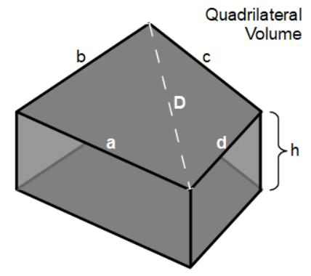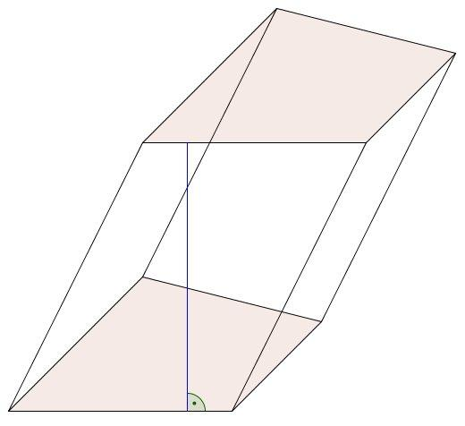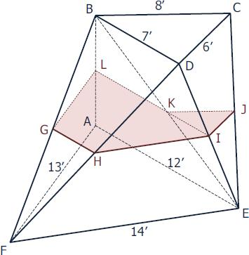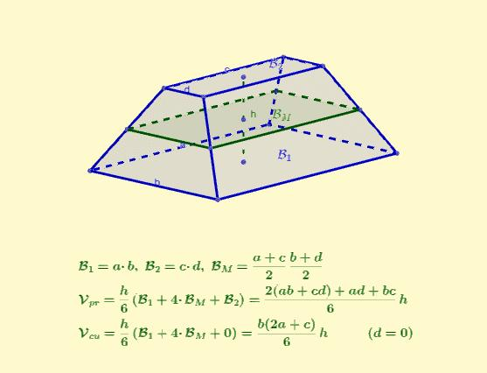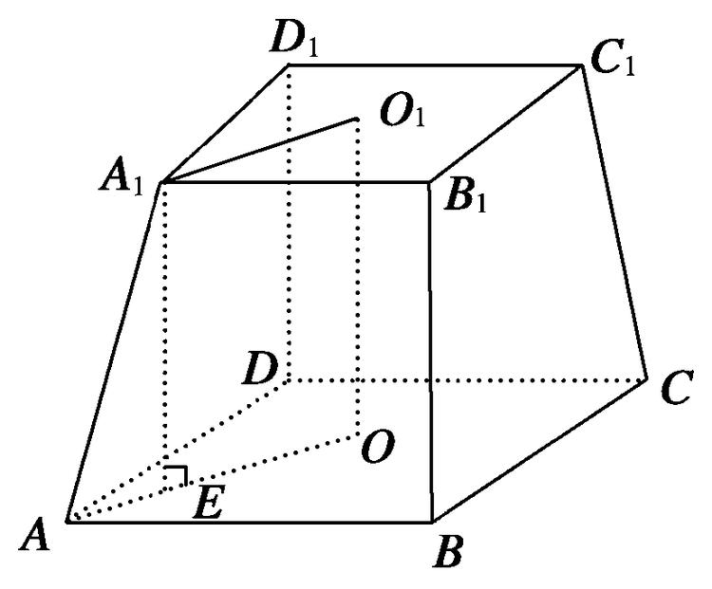
- Quadrilateral Prism: A special case with congruent parallel quadrilateral bases.
- Pyramidal Frustum: A related solid with similar polygonal bases.
- Quadrilateral Prismatoid: A broader related geometric category.
- Parallelepiped: A related solid whose bases and lateral faces are parallelograms.

Main Classification
# Source: AI Source: Provided by: [Data Path: Persons Table -> ID Column: 1, Name_En Column: Motasem Essam] -> From: [ChatGPT] on [7/25/2026]
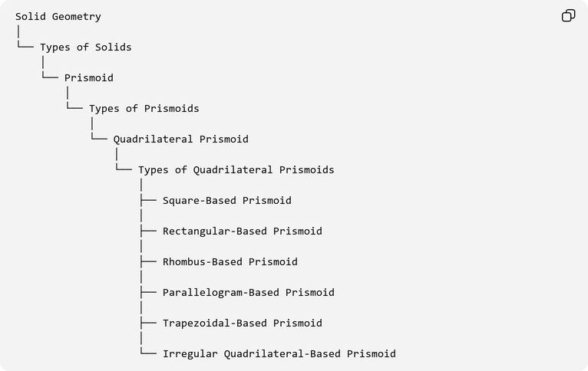
Solid Geometry
│
└── Types of Solids
│
└── Prismoid
│
└── Types of Prismoids
│
└── Quadrilateral Prismoid
│
└── Types of Quadrilateral Prismoids
│
├── Square-Based Prismoid
│
├── Rectangular-Based Prismoid
│
├── Rhombus-Based Prismoid
│
├── Parallelogram-Based Prismoid
│
├── Trapezoidal-Based Prismoid
│
└── Irregular Quadrilateral-Based Prismoid

Key Points
# Source: AI Source: Provided by: [Data Path: Persons Table -> ID Column: 1, Name_En Column: Motasem Essam] -> From: [ChatGPT] on [7/25/2026]
- An irregular quadrilateral-based prismoid has two parallel quadrilateral bases.
- Its bases have irregular shapes and may differ in dimensions.
- It contains four quadrilateral lateral faces.
- It has 6 faces, 12 edges, and 8 vertices.
- Its lateral faces may be trapezoids or parallelograms.
- Its lateral edges may be inclined.
- Its height is the perpendicular distance between the two base planes.
- Its volume is calculated using the prismoidal formula.
- The corresponding vertices must be arranged so that all four lateral faces are planar.

Conclusion
# Source: AI Source: Provided by: [Data Path: Persons Table -> ID Column: 1, Name_En Column: Motasem Essam] -> From: [ChatGPT] on [7/25/2026]
An Irregular Quadrilateral-Based Prismoid is a member of the quadrilateral prismoid family characterized by two parallel quadrilateral bases with irregular shapes and dimensions. Its four lateral quadrilateral faces connect the corresponding vertices of the bases, creating a three-dimensional solid with six faces, twelve edges, and eight vertices. Its flexible base geometry allows different configurations and makes it an important example of quadrilateral-based prismoids.

